 | 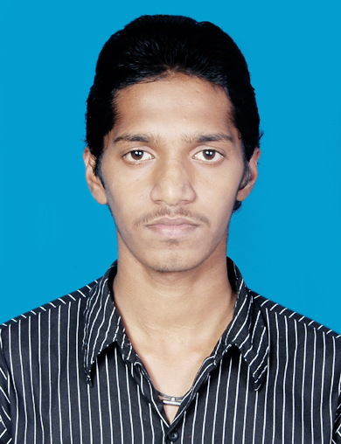  CONTACT ADDRESS  ANIL KUMAR SWAIN  S/o Simanchal swain  Ashwnilayout,Ejipur  Koramangala,  Bangalore 47  MOBILE NUMBER  +91-7537963289  E-MAIL ID  Anilkumarswain92@gmail.com | CAREER OBJECTIVE:  To enhance and develop my technical skills and continually learn about the latest paradigm and processes and to fulfill my needs and aspirations along with the organization with loyalty and honesty  WORK EXPERIENCE  - Fresher  ACADEMIC PROFILES  SEMINAR  - Underground Cable  TECHNICAL PROJECTS  - Solar Power Plant
  Degree | Year of Passing | Institute/University | Percentage of marks
  B.TECH  ( Electrical Engineering) | 2015 | BPUT  Satyasai Engg.college  Balasore,Odisha | 65%
  Diploma  ( Electrical Engineering) | 2012 | SCTE&VT (Odisha)  MITS school of engg,janala,BHUBANESWAR | 70%
  ITI  ( Electrician) | 2009 | AICTEVT (Odisha)  Ganesh institute of engg. And tech.BBSR | 85%
  10th | 2007 | B.S.E  Govt. High school,ph-2  C s pur, Bhubaneswar | 52%
PERSONAL DETAILS  Name: Anil kumar swain  Father Name: Simanchal swain  DOB: 05/05/1992  Sex: Male  Nationality: Indian  Languages Known:  English, Hindi,Oriya  Permanet Address:  Anil kumar swain  S/o Simanchal swain  L.i.g 15/1,  Housingboard colony,  Chandrasekharpur,  Bhubaneswar  Pin-751016  Dist: Khurdha  ODISHA  Strength :  Hard Working  Smart Working  Trust Worthy  Marital Status: Unmarried  HOBBIES:  Listening to music  Reading newspaper  Playing Cricket |  | COMPUTER PROFICIENCY  OPERATING SYSTEM : WINDOWS 98, XP,Vista  Windows 7  Microsoft office  Language Known : .Net  JOB SKILLS  - Ability to work in a team.  - Committed to work in project deadlines and schedules.  ACHIVEMENTS  - Got a wireman “B” Lincese from Govt.of Odisha,Electrical  Board.  SOFT SKILLS  - Ability to easily acquire and learn new technology.  - Ability to deal with people diplomatically.  - Self Confident  - Positive attitute.  - Flexibility.  DECLARATION  I hereby solemnly affirm that all the details provided above are true to the best of my knowledge.  Date :  Place : Anil kumar swain

